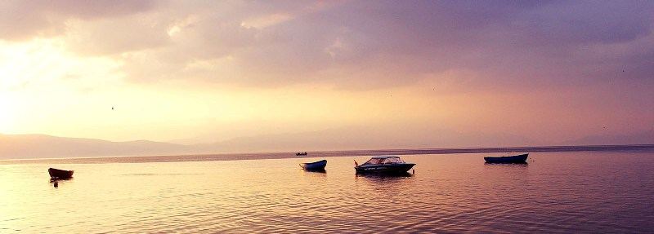
eTwinning Professional Development Workshop,
Lake Ohrid
November 20th – November 22th , 2015

Integration of ICT innovative techniques
from the eTwinning projects into the curriculum

Friday November 20th

14h00 Registration and Welcome Coffee
14h30 Opening Speeches
- Mr. Darko Dimitrov, Director of the National Agency – TBC
- Representative of Ministry of Education and Science
- Mr. Mustafa Hakan BÜCÜK, Turkish Ministry of National Education, Head of R&D Department
- Claire Morvan, CSS – European Schoolnet – TBC
15h15 Keynote Speaker (Mrs. Bettina Ziedler): Topic to be defined
16.00 Coffee break
16.30 Keynote Speaker (Mrs. Anne McMorrough): Topic to be defined
17.15 Networking Actvity – Sharing Project Ideas (TR NSS, Mr. Mehmet Fatih Döğer- Mr. Can Erdoğan)
19h30 Dinner

Saturday November 21th

9h00 Introduction of the agenda
9h15 How to Plan a Creative eTwinning Project ( TR-Teacher- Mrs. Joanna GÜRPINAR)
10h00 Coffee break
10h30 Workshops 1,2,3,4
13h00 Lunch
14.00 Workshops 1,2,3,4
15.30 Break
16.00 Workshop 1,2,3,4
18.00 Departure with bus to Ohrid / Sightseeing;
20.30 Dinner

Sunday November 22th

09h00 Introduction of the agenda
09h15 Workshop 1,2,3,4
10h45 Coffee break
11h15 Good practice examples (TR Teachers; Mrs. Deniz Şengül / Mrs. Lamia Büşra Yeşil/ Mr. Arif Bozkurt)
12h00 Project Presentations and conclusions
13h00 Lunch
15.00 Presentation (Mrs. Marina Vasileva): Creativity in the educational process “The Grandma’s Games” (http://grandmasgames.blogspot.com/)

Workshop 1 (MK NSS- Coordinator -, Mr. Dejan Zlatkovski) : The ICT and the Education
Workshop 2 (TR NSS- Ambassador – Mr. Adil TUĞYAN): Essence Based Learning and its stages
Workshop 3 (TR NSS, Ambassador- Mr. Buğra İNAL): Game based learning via eTwinning
Workshop 4 (TR NSS, Mr. Can ERDOĞAN): Planning and writing good eTwinning Project

